**INSERT BUSINESS NAME HERE**

INSERT BUSINESS IMAGE OR LOGO BELOW



(LOGO OR PHOTO)

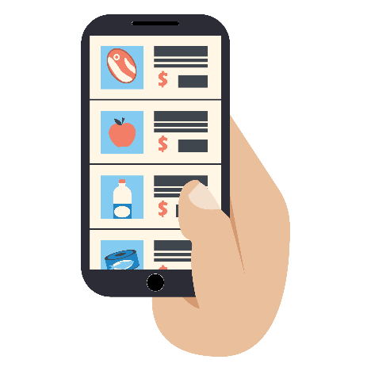

**INSERT BUSINESS WHATSAPP/PHONE NUMBER HERE**

**THANK YOU FOR SUPPORTING XYZ, A LOCAL BUSINESS!**

**BY COMMUNICATING WITH THE NUMBER ABOVE, WE OFFER: (List your business offerings)**

**PAYMENT METHODS (Select the ones that apply to your business):**

**1) Cash**

**2) Credit cards: VISA / Mastercard**

**3) Mobile Wallet**

* WhatsApp orders
* Home delivery
* Take - away
* Product catalogs and daily promotions