INSERT BUSINESS NAME HERE
INSERT BUSINESS LOGO OR BUSINESS IMAGE BELOW (LOGO OR PHOTO)
INSERT BUSINESS WHATSAPP NUMBER HERE
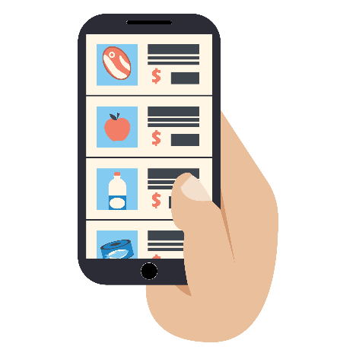
THANK YOU FOR SUPPORTING AND HELPING LOCAL SMALL BUSINESSES!
THROUGH COMMUNICATION WITH OUR WHATSAPP NUMBER, WE OFFER:

- WhatsApp orders
- Home delivery
- Take - away
- Product catalogs and daily promotions

RECOMMENDATIONS:
- Complete your profile with the number of your business and in the information section, include your business name and address.
- Put the sign in a visible place so that clients could take note or a picture to have your business information.
- If you want to send this profile, delete this second recommendation sheet; and send to customers as a PDF instead of Word.
- To save as a PDF, you only have to: 1) Save as 2) Instead of Word document, find the PDF option 3) Save PDF version.

